**MY SQL QUERIES**

**COFFEE SHOP SALES PROJECT**

**Creating the table coffee_shop and loading the data in table from csv file**

create table coffee_shop(

transaction_id int primary key,

transaction_date date,

transaction_time time,

transaction_qty float,

store_id int,

store_location varchar(50),

product_id int,

unit_price float,

product_category varchar(50),

product_type varchar(50),

product_detail varchar(50)

);

copy coffee_shop

from 'D:\Coffee Shop Analysis(SQL + Power BI)\Coffee Shop Sales.csv'

delimiter ','

csv header

**TOTAL SALES**

ALTER TABLE coffee_shop ADD COLUMN Total_Sales float;

update coffee_shop

set Total_sales=transaction_qty * unit_price;

SELECT ROUND(SUM(Total_Sales)) as Total_Sales

FROM coffee_shop_sales

WHERE EXTRACT(MONTH FROM transaction_date) = 5 -- for month of (CM-May)

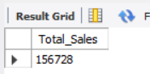

**TOTAL SALES KPI - MOM DIFFERENCE AND MOM GROWTH**

SELECT

EXTRACT(MONTH FROM transaction_date) AS Month,

round(SUM(Total_Sales)) AS Total_Sales,

(SUM(Total_Sales) - LAG(SUM(Total_Sales),1) OVER (ORDER BY EXTRACT(MONTH FROM transaction_date) asc)) /

LAG(SUM(Total_Sales)) OVER (ORDER BY EXTRACT(MONTH FROM transaction_date)) * 100 AS mom_increase_percentage

FROM

coffee_shop

WHERE

EXTRACT(MONTH FROM transaction_date) IN (4, 5)

GROUP BY

EXTRACT(MONTH FROM transaction_date),

TO_CHAR(transaction_date, 'Month')

ORDER BY

EXTRACT(MONTH FROM transaction_date);

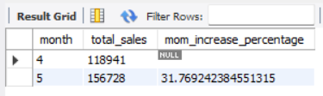

**TOTAL ORDERS**

SELECT COUNT(transaction_id) as Total_Orders

FROM coffee_shop_sales

WHERE EXTRACT(MONTH FROM transaction_date)= 5 -- for month of (CM-May)

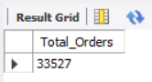

**TOTAL ORDERS KPI - MOM DIFFERENCE AND MOM GROWTH**

SELECT

EXTRACT(MONTH FROM transaction_date) AS Month,

count(transaction_id) AS Total_Orders,

cast(((count(transaction_id) - LAG(count(transaction_id),1)

OVER (ORDER BY EXTRACT(MONTH FROM transaction_date)))*1.0

/LAG(count(transaction_id),1) OVER (ORDER BY EXTRACT(MONTH FROM transaction_date)))* 100.00 as decimal(10,2)) AS mom_increase_percentage

FROM

coffee_shop

WHERE

EXTRACT(MONTH FROM transaction_date) IN (4, 5)

GROUP BY

EXTRACT(MONTH FROM transaction_date),

TO_CHAR(transaction_date, 'Month')

ORDER BY

EXTRACT(MONTH FROM transaction_date);

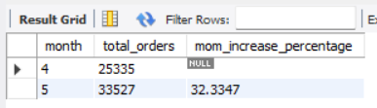

**TOTAL QUANTITY SOLD**

SELECT SUM(transaction_qty) as Total_Quantity_Sold

FROM coffee_shop_sales

WHERE EXTRACT(MONTH FROM transaction_date) = 5 -- for month of (CM-May)

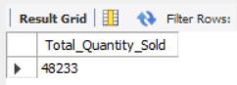

**TOTAL QUANTITY SOLD KPI - MOM DIFFERENCE AND MOM GROWTH**

SELECT

EXTRACT(MONTH FROM transaction_date) AS month,

ROUND(SUM(transaction_qty)) AS total_quantity_sold,

cast((SUM(transaction_qty) - LAG(SUM(transaction_qty), 1)

OVER (ORDER BY EXTRACT(MONTH FROM transaction_date)))*1.0

/ LAG(SUM(transaction_qty), 1) OVER (ORDER BY EXTRACT(MONTH FROM transaction_date))) * 100 as decimal(10,4))

AS mom_increase_percentage

FROM

coffee_shop

WHERE

EXTRACT(MONTH FROM transaction_date) IN (4, 5) -- for April and May

GROUP BY

EXTRACT(MONTH FROM transaction_date)

ORDER BY

EXTRACT(MONTH FROM transaction_date);

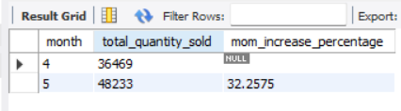

**CALENDAR TABLE – DAILY SALES, QUANTITY and TOTAL ORDERS**

select * from coffee_shop;

select count(transaction_id) as total_orders,

sum(transaction_qty) as total_quantity,

sum(total_sales) as total_price

from coffee_shop

where transaction_date='2023-05-18'; --For 18 May 2023

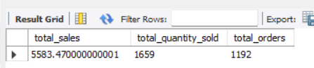

***If you want to get exact Rounded off values then use below query to get the result:***

select concat(cast(count(transaction_id)*1.0/1000 as decimal(10,1)),'K') as total_orders,

concat(cast(sum(transaction_qty)/1000 as decimal(10,1)),'K') as total_quantity,

concat(cast(sum(total_sales)/1000 as decimal(10,1)),'K') as total_price

from coffee_shop

where transaction_date='2023-05-18'; --For 18 May 2023

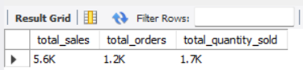

**SALES TREND OVER PERIOD**

select avg(totals) as average_sales

from

(

select transaction_date,sum(total_sales) as totals

from coffee_shop

where extract(month from transaction_date)=5

group by transaction_date

) as innerquery

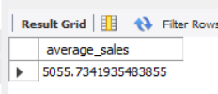

**DAILY SALES FOR MONTH SELECTED**

SELECT

DAY(transaction_date) AS day_of_month,

ROUND(SUM(total_sales),1) AS total_sales

FROM

coffee_shop_sales

WHERE

MONTH(transaction_date) = 5 -- Filter for May

GROUP BY

DAY(transaction_date)

ORDER BY

DAY(transaction_date);

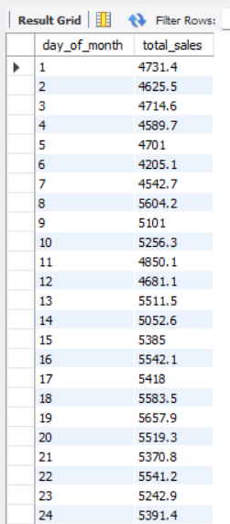 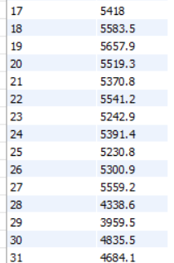

***COMPARING DAILY SALES WITH AVERAGE SALES – IF GREATER THAN “ABOVE AVERAGE” and LESSER THAN “BELOW AVERAGE”***

SELECT

day_of_month,

CASE

WHEN total_sales > avg_sales THEN 'Above Average'

WHEN total_sales < avg_sales THEN 'Below Average'

ELSE 'Average'

END AS sales_status,

total_sales

FROM (

SELECT

DAY(transaction_date) AS day_of_month,

SUM(total_sales) AS total_sales,

AVG(SUM(unit_price * transaction_qty)) OVER () AS avg_sales

FROM

coffee_shop_sales

WHERE

MONTH(transaction_date) = 5 -- Filter for May

GROUP BY

DAY(transaction_date)

) AS sales_data

ORDER BY

day_of_month;

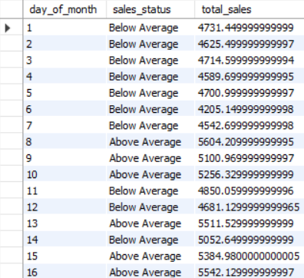 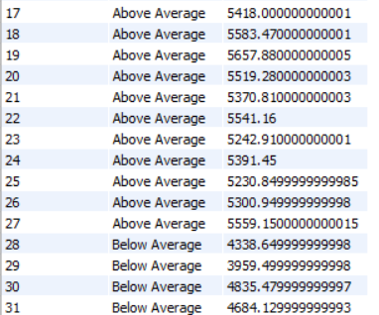

**SALES BY WEEKDAY / WEEKEND:**

SELECT

CASE

WHEN DAYOFWEEK(transaction_date) IN (1, 7) THEN 'Weekends'

ELSE 'Weekdays'

END AS day_type,

ROUND(SUM(total_sales),2) AS total_sales

FROM

coffee_shop_sales

WHERE

MONTH(transaction_date) = 5 -- Filter for May

GROUP BY

CASE

WHEN DAYOFWEEK(transaction_date) IN (1, 7) THEN 'Weekends'

ELSE 'Weekdays'

END;

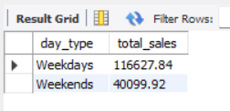

**SALES BY STORE LOCATION**

SELECT

store_location,

SUM(total_sales) as Total_Sales

FROM coffee_shop_sales

WHERE

MONTH(transaction_date) =5

GROUP BY store_location

ORDER BY SUM(unit_price * transaction_qty) DESC

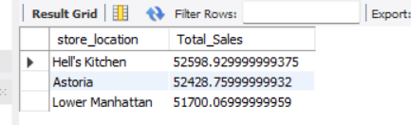

**SALES BY PRODUCT CATEGORY**

SELECT

product_category,

ROUND(SUM(total_sales),1) as Total_Sales

FROM coffee_shop_sales

WHERE

MONTH(transaction_date) = 5

GROUP BY product_category

ORDER BY SUM(unit_price * transaction_qty) DESC

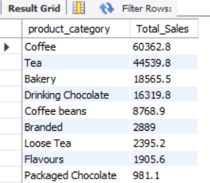

**SALES BY PRODUCTS (TOP 10)**

SELECT

product_type,

ROUND(SUM(total_sales),1) as Total_Sales

FROM coffee_shop_sales

WHERE

MONTH(transaction_date) = 5

GROUP BY product_type

ORDER BY Total_Sales DESC

LIMIT 10

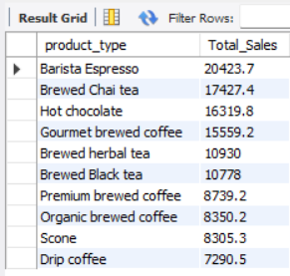

**SALES BY DAY | HOUR**

SELECT

ROUND(SUM(unit_price * transaction_qty)) AS Total_Sales,

SUM(transaction_qty) AS Total_Quantity,

COUNT(*) AS Total_Orders

FROM

coffee_shop_sales

WHERE

DAYOFWEEK(transaction_date) = 3 -- Filter for Tuesday (1 is Sunday, 2 is Monday, ..., 7 is Saturday)

AND HOUR(transaction_time) = 8 -- Filter for hour number 8

AND MONTH(transaction_date) = 5; -- Filter for May (month number 5)

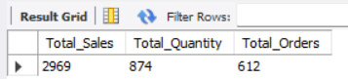

***TO GET SALES FROM MONDAY TO SUNDAY FOR MONTH OF MAY***

SELECT

CASE

WHEN DAYOFWEEK(transaction_date) = 2 THEN 'Monday'

WHEN DAYOFWEEK(transaction_date) = 3 THEN 'Tuesday'

WHEN DAYOFWEEK(transaction_date) = 4 THEN 'Wednesday'

WHEN DAYOFWEEK(transaction_date) = 5 THEN 'Thursday'

WHEN DAYOFWEEK(transaction_date) = 6 THEN 'Friday'

WHEN DAYOFWEEK(transaction_date) = 7 THEN 'Saturday'

ELSE 'Sunday'

END AS Day_of_Week,

ROUND(SUM(unit_price * transaction_qty)) AS Total_Sales

FROM

coffee_shop_sales

WHERE

MONTH(transaction_date) = 5 -- Filter for May (month number 5)

GROUP BY

CASE

WHEN DAYOFWEEK(transaction_date) = 2 THEN 'Monday'

WHEN DAYOFWEEK(transaction_date) = 3 THEN 'Tuesday'

WHEN DAYOFWEEK(transaction_date) = 4 THEN 'Wednesday'

WHEN DAYOFWEEK(transaction_date) = 5 THEN 'Thursday'

WHEN DAYOFWEEK(transaction_date) = 6 THEN 'Friday'

WHEN DAYOFWEEK(transaction_date) = 7 THEN 'Saturday'

ELSE 'Sunday'

END;

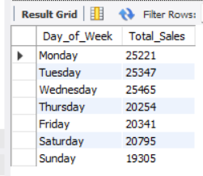

***TO GET SALES FOR ALL HOURS FOR MONTH OF MAY***

SELECT

HOUR(transaction_time) AS Hour_of_Day,

ROUND(SUM(unit_price * transaction_qty)) AS Total_Sales

FROM

coffee_shop_sales

WHERE

MONTH(transaction_date) = 5 -- Filter for May (month number 5)

GROUP BY

HOUR(transaction_time)

ORDER BY

HOUR(transaction_time);

